Multi-Stage Exploitation and Security Assessment
Week-04
Name : Manish Tiruwa
Date : 14/04/2026
Environment : Kali Linux (Virtual Machine)

Advanced Exploitation Techniques
Exploit Chaining (Multi-Stage Attacks) :
Exploit chaining involves combining multiple vulnerabilities to achieve a goal that a single flaw could not reach.
- The Concept: An attacker might use a low-severity bug to gain a foothold and then "pivot" to a high-severity vulnerability.
- Example (XSS to RCE): A researcher uses Cross-Site Scripting (XSS) to steal an administrator's session cookie. Once the session is hijacked, they use administrative privileges to upload a malicious script (Web Shell) to the server, resulting in Remote Code Execution (RCE).
- Example (CSRF to SQLi): An attacker uses Cross-Site Request Forgery (CSRF) to force an admin’s browser to submit a request. That request contains a SQL Injection payload, allowing the attacker to bypass authentication or dump the database.
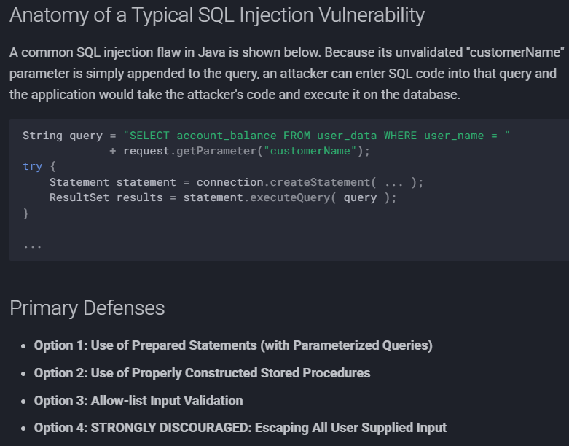
Figure 01: SQL Injection
Custom Exploit Development :
While public repositories like Exploit-DB provide Proof of Concepts (PoCs), modern environments often require customization.
- Modification: Changing a PoC to match a specific target's architecture or memory offsets.
- Heap Overflows & Spraying: In languages like Python, an attacker might write a script for "Heap Spraying." This involves "coating" the system's memory with a specific payload (the NOP slide and shellcode) to increase the reliability of an exploit targeting a heap overflow.
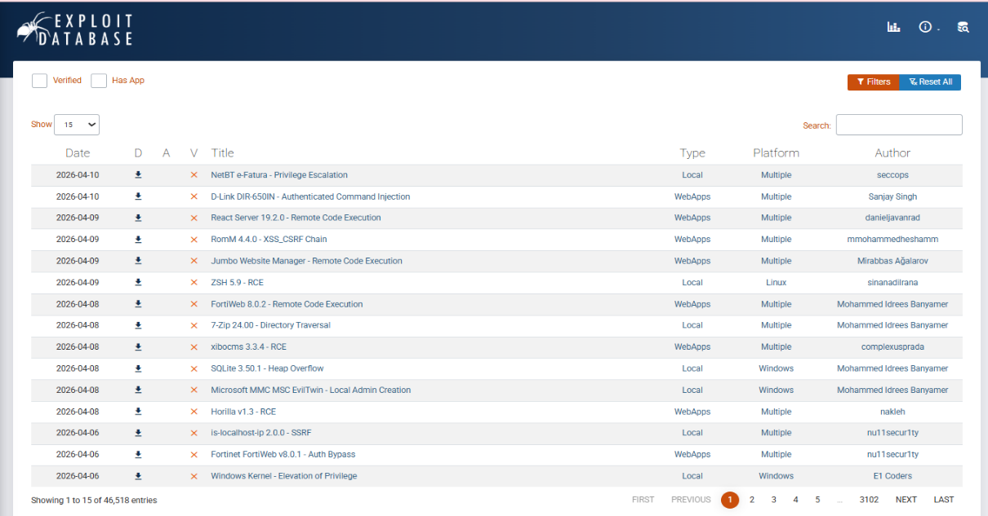
Figure 02: Exploit-DB Advanced PoCs

Bypassing Modern Defenses :
Modern systems use ASLR (Address Space Layout Randomization) and DEP (Data Execution Prevention) to stop standard exploits.
- ROP (Return-Oriented Programming): A technique used to bypass DEP by executing snippets of existing code (gadgets) already in the system memory.
- WAF Evasion: Using polymorphic payloads or encoding to slip past a Web Application Firewall.
Defense | Description | Bypass Technique
ASLR | Randomizes where data is stored in memory | Memory Leaks or Return-Oriented Programming (ROP).
DEP/NX | Prevents code from executing in data-only memory segments. | ROP Chains (using existing code "gadgets" already in memory).
WAF | Filters malicious web traffic. | Polymorphic Payloads or Encoded/Escaped Inputs.

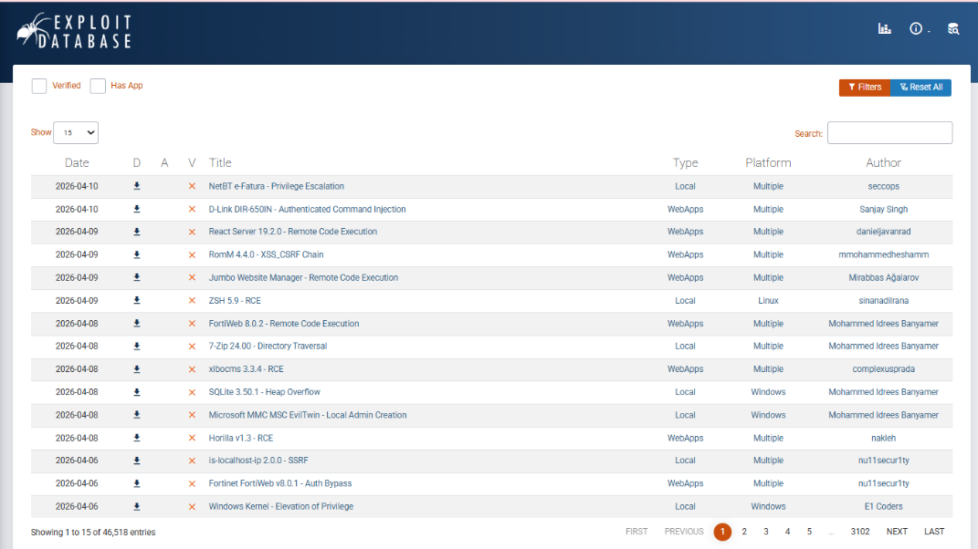
Figure 03:Exploit-DB Advaced PoCs

Master Objective: Remediation
To demonstrate a complete understanding, this report includes the primary defense against these advanced exploitation techniques.
- Parameterized Queries: By using Prepared Statements, the database is forced to treat input strictly as data, making exploit chaining and custom injection attempts ineffective.

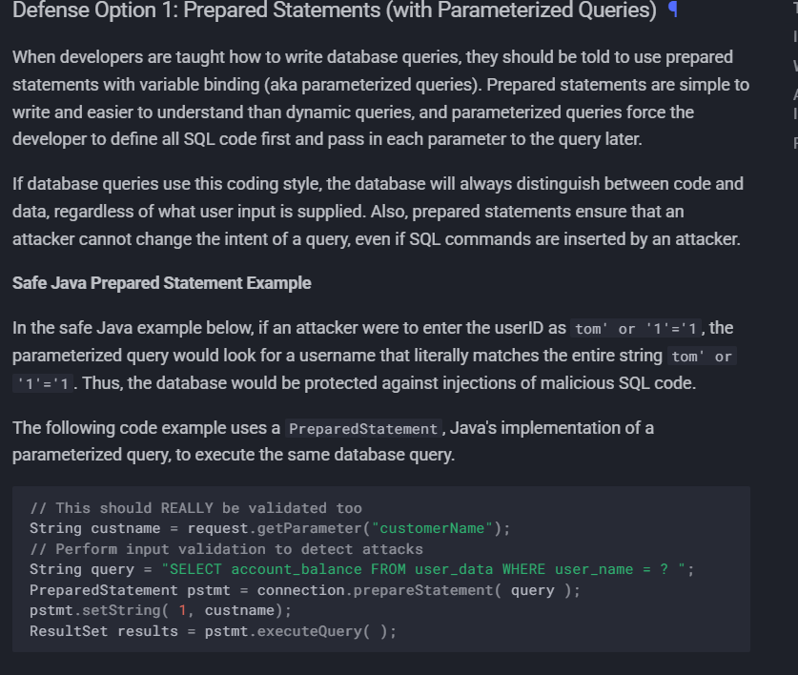

Figure 04: "Safe Java Prepared Statement Example" code block.

API Security Testing & Defense

API Vulnerabilities (OWASP API Top 10) :
Modern applications rely on APIs, which introduces unique risks compared to traditional web apps.
- A01:2023 Broken Object Level Authorization (BOLA): This is the most common API flaw. It occurs when an application does not check if the user requesting a specific "object" (like a user profile or a bank statement) actually has permission to see it.
- Example: An attacker changes a URL from /api/v1/user/100/profile to /api/v1/user/101/profile and successfully views another person's private data.
- Broken Authentication: Weaknesses in how tokens (like JWTs) are signed or expired can allow an attacker to impersonate any user.
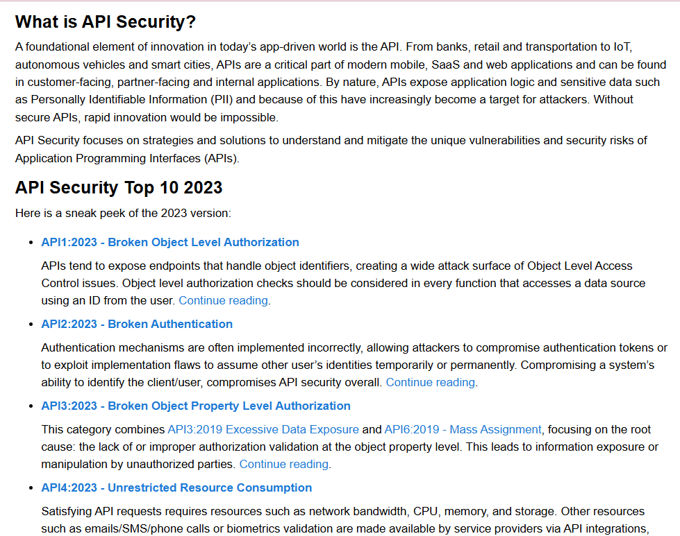
Figure 05: "API1:2023 Broken Object Level Authorization."

Testing Techniques & Tooling :
Testing APIs requires a mix of manual "uncovering" and automated "fuzzing."
- Endpoint Enumeration: Using Burp Suite or Postman to find "hidden" endpoints. Often, developers leave old versions of an API active (e.g., /api/v1/ and /api/v2/). The older version might lack security controls.
- Fuzzing: Using Postman’s Collection Runner or Burp Intruder to send hundreds of variations of a request to see how the API handles unexpected characters or large numbers.
- Manual Inspection: Looking at the API’s OpenAPI (Swagger) documentation to understand the structure of requests and required parameters.
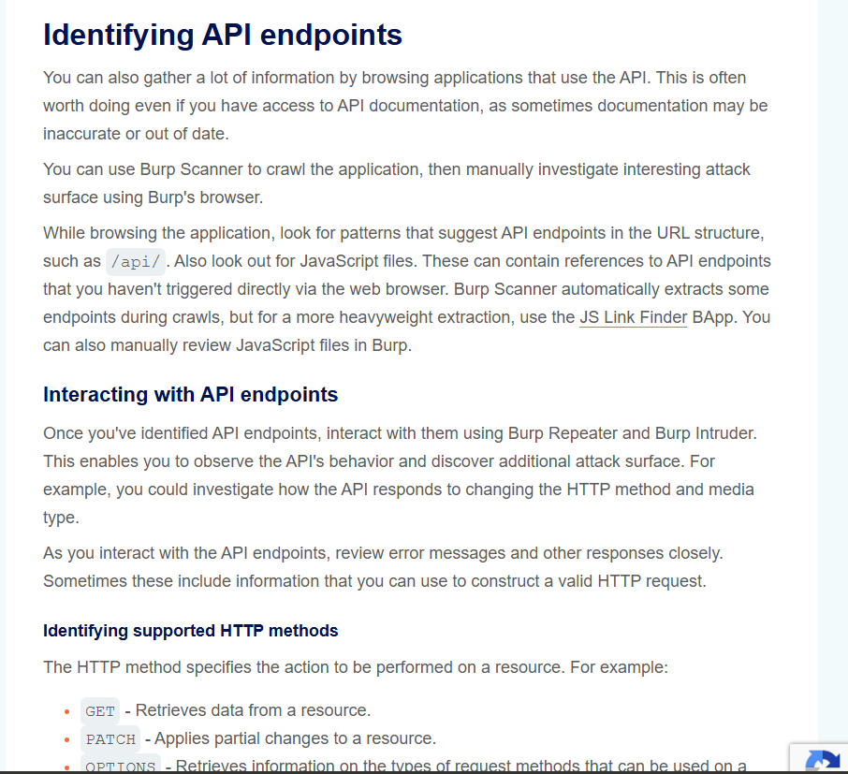
Figure 06: Identifying API Endpoint

Rate Limiting and Advanced Injection :
Security is not just about authorization; it’s about preventing resource abuse.
- Bypassing Rate Limits: Attackers might try to bypass "request per minute" limits by using multiple IP addresses, changing their User-Agent strings, or adding "junk" parameters to the URL to trick the server's cache.
- GraphQL Injection: Unlike standard SQL, GraphQL allows clients to ask for exactly the data they want. An attacker can inject a query that asks for the entire database schema (introspection query) or creates a "circular query" that crashes the server.
- Mass Assignment: Injecting extra parameters into a JSON request to change data fields that shouldn't be editable, like changing "is_admin": false to "is_admin": true.
The Pyload :
{
__schema {
queryType { name }
mutationType { name }
types {
name
fields {
name
type {
name
kind
}
}
}
}
}

Key Objectives & Learning Resources :
To achieve expertise in API pentesting, the following learning path is followed:
- OWASP API Security Project: For the standard list of what to test.
- PortSwigger Academy: Hands-on labs for practicing BOLA and Authentication bypasses.
- SANS Institute Case Studies: To understand how real-world breaches (like the Optus or T-Mobile API breaches) occurred.

Privilege Escalation (Vertical Movement) :
Once initial access is gained, the objective is to elevate privileges to the highest level (Root on Linux, SYSTEM on Windows).
- Kernel Exploits: Targeting vulnerabilities in the operating system's core to execute code as the highest authority.
- SUID Binaries (Linux): Finding files with the "Set User ID" bit. If a binary owned by root has this bit and is misconfigured (e.g., a text editor that can read /etc/shadow), a user can escalate their privileges.
- Misconfigured Services: Exploiting services that run with high privileges but have weak permissions, allowing an attacker to replace the service executable with a malicious one.
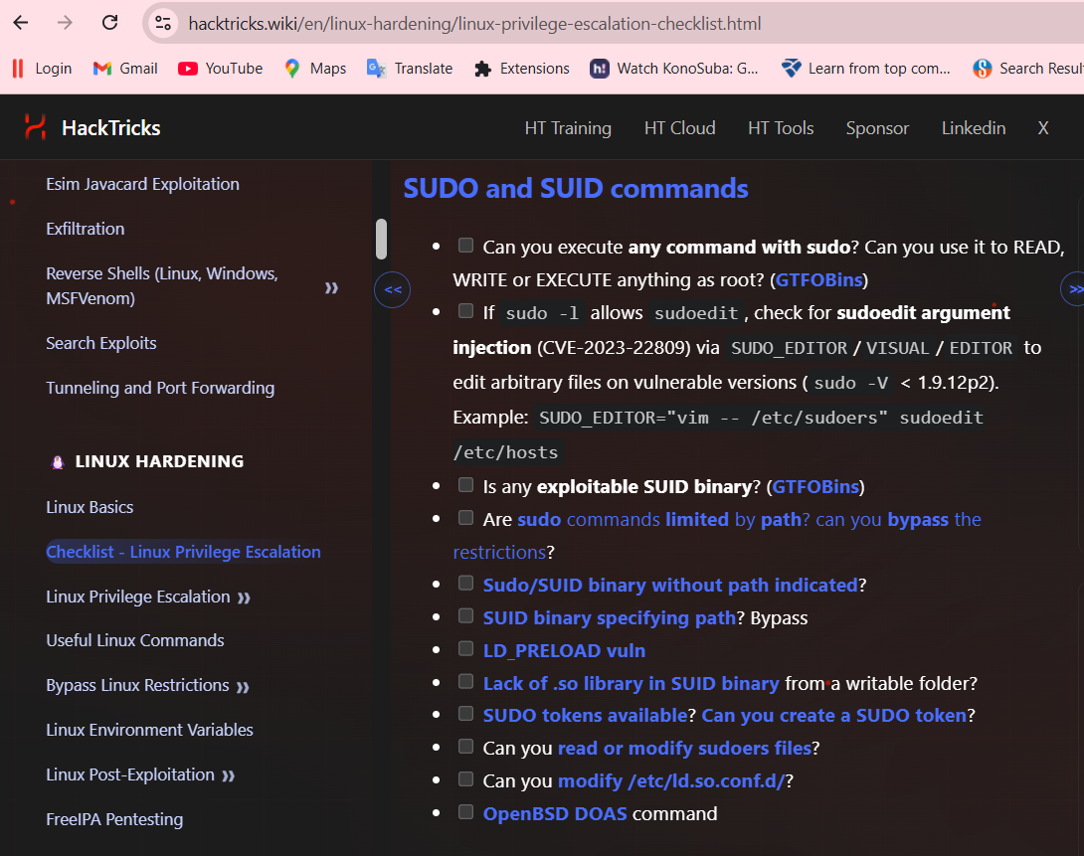
Figure 07: HackTricks - Linux Privilege Escalation

Persistence Mechanisms :
Persistence ensures that an attacker maintains access even after a system reboot or password change.
- Cron Jobs (Linux): Scheduling a recurring task that executes a "Reverse Shell" every 5 minutes.
- Registry Keys (Windows): Adding a malicious entry to the Run or RunOnce keys so the malware starts every time a user logs in.
- Malicious Services: Creating a hidden background service that automatically reconnects to the attacker's server.
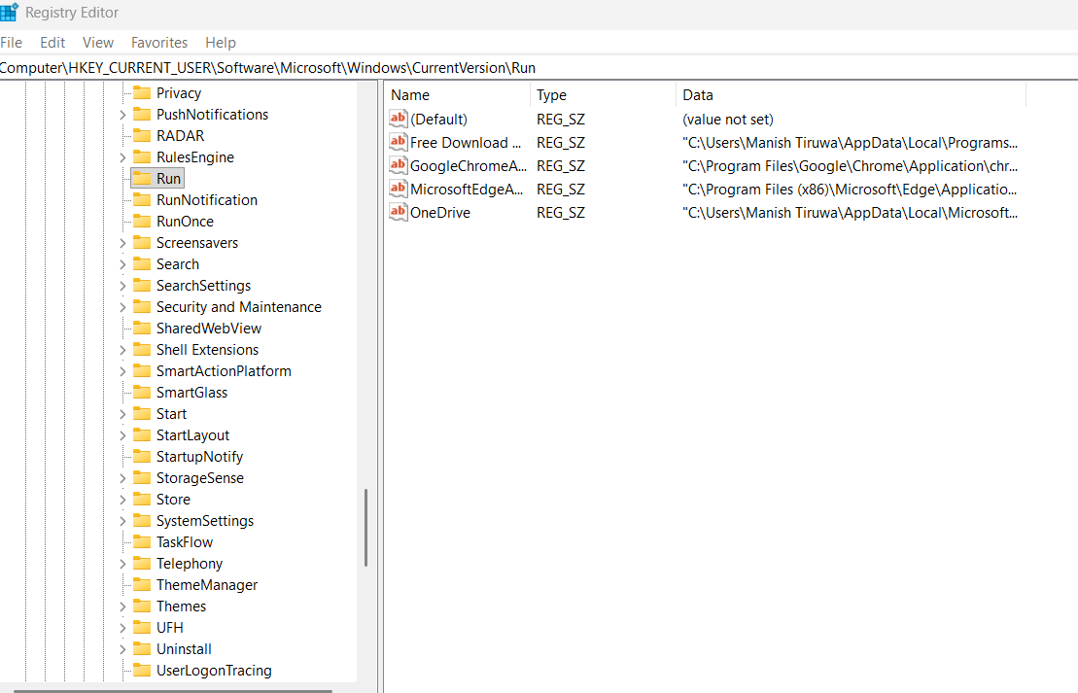
Figure 08: Current Version

Living-off-the-Land (LotL) :
Living-off-the-Land involves using legitimate, pre-installed system tools to perform malicious actions. This is highly effective because it often bypasses Antivirus/EDR.
- PowerShell & WMI: Using Windows Management Instrumentation (WMI) to execute commands remotely or schedule tasks without dropping new files on the disk.
- LOLBAS/GTFOBins: Using native binaries like find, vim, or certutil to download files or escalate privileges. Since these are "trusted" system files, they do not trigger security alerts.
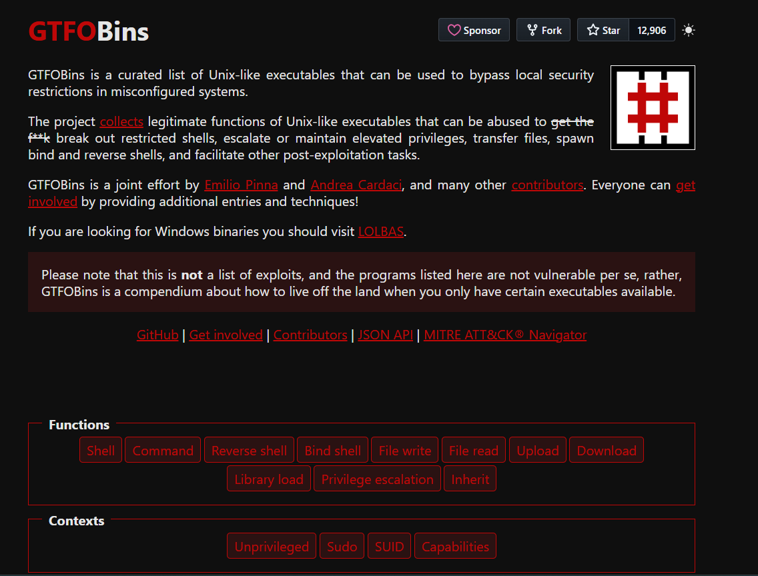
Figure 09: GTFIBins

Summary :
To master the advanced techniques of Exploitation, API Security, and Privilege Escalation, this study utilized a multi-layered approach based on industry-leading research and training platforms.

Network Protocol Attacks & Interception

Protocol Exploitation :
Network protocols like SMB, DNS, and SNMP often have inherent weaknesses or legacy flaws that can be weaponized.
- SMB Relay Attacks: Instead of cracking a password, an attacker captures a user's NTLM hash and "relays" it to another machine on the network to gain access as that user.
- SNMP Exploitation: Many organizations use the default "public" community string. An attacker can use this to "walk" the SNMP tree and discover sensitive information like running processes, network interfaces, and sometimes even cleartext credentials.
- DNS Attacks: Targeting the infrastructure that translates names to IPs. This includes Zone Transfers (AXFR) to map an entire internal network.
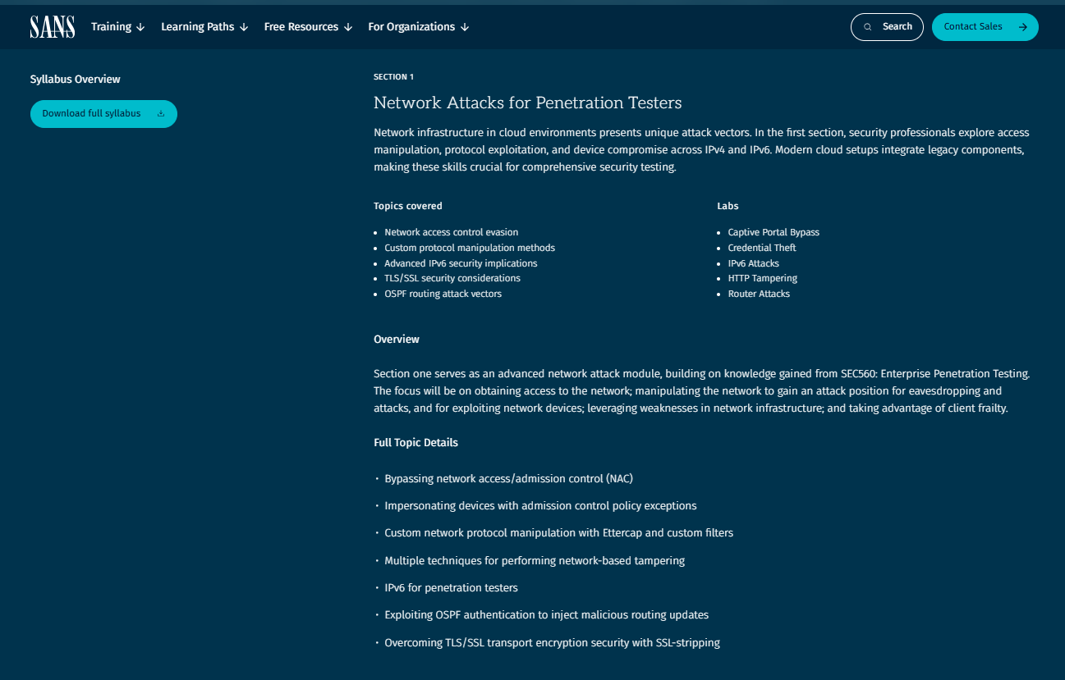
Figure 10: Network Attacks for Penetration Tester

Man-in-the-Middle (MitM) :
MitM attacks place the attacker between two communicating parties to intercept or modify traffic.
- ARP Spoofing: Sending fake ARP messages to a local network to associate the attacker’s MAC address with the IP address of a legitimate server (like the gateway).
- DNS Poisoning: Injecting false entries into a DNS cache so that users are redirected to a malicious website when they type in a legitimate URL.
- SSL Stripping: Forcing a browser to use HTTP instead of HTTPS by intercepting the initial handshake, allowing the attacker to see sensitive data in cleartext.
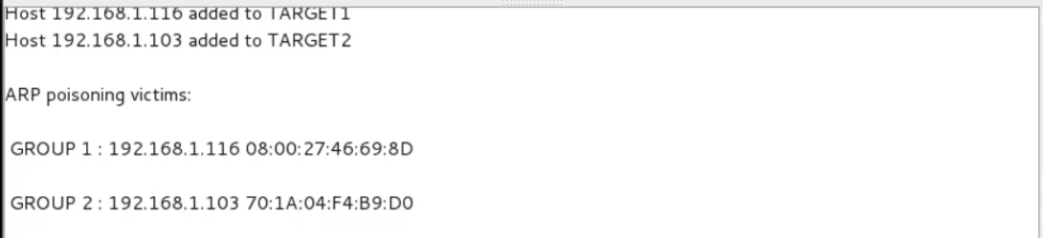
Figure 11: ARP Poisoning

Protocol Misconfigurations :
Often, the protocol itself is secure, but the way it is set up is not.
- Cleartext Protocols: Using Telnet, FTP, or HTTP instead of their encrypted counterparts (SSH, SFTP, HTTPS). Anyone on the same network can "sniff" the traffic and see passwords.
- Legacy Protocols: Keeping SMBv1 active (vulnerable to EternalBlue) or LLMNR/NetBIOS enabled, which are the primary targets for credential harvesting in modern Windows environments.
Fast Port Scan : masscan -p20,21-23,25,53,80,110,111,135,139,143,443,445,993,995,1723,3306,3389,5900,8080 199.66.11.0/24
fast port scanner (masscan) and a list of the ports more used: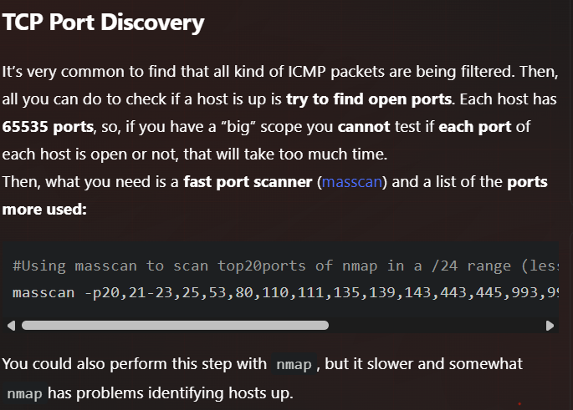
Figure 12: TCP Port Discovery

Summary :

The core of network protocol security is Encryption and Validation. By moving from cleartext to encrypted protocols and disabling legacy services (like SMBv1 and LLMNR), most of the attacks discussed in this report are mitigated.
Would you like a sample Responder log or a Wireshark packet capture analysis to include as a technical exhibit for this part of your report?

Mobile Application Penetration Testing :

1. Mobile Vulnerabilities (OWASP Mobile Top 10)
Mobile security risks often stem from how the app interacts with the mobile operating system (Android/iOS) and how it handles local data.
- M1: Improper Platform Usage: This involves failing to use the security features provided by the platform.
  - Example: Storing sensitive data in a globally readable file instead of using the Android Keystore or iOS Keychain.
- M2: Insecure Data Storage: Many apps inadvertently leak data.
  - Example: An attacker extracts an Android APK, decompiles it, and finds hardcoded API keys or sensitive user data cached in the /data/data/com.app.name/databases/ directory.
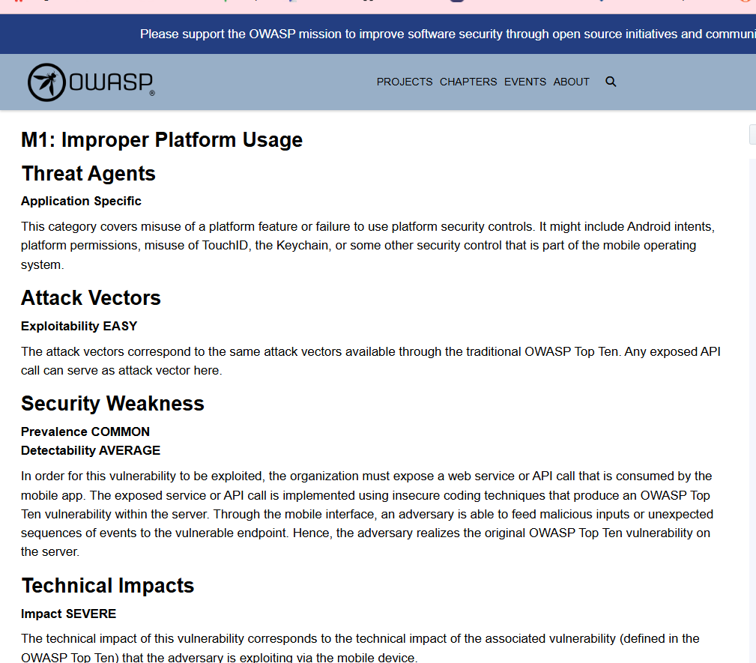
Figure 13: "M1: Improper Platform Usage

Testing Techniques (Static & Dynamic) :
To find these vulnerabilities, you must use a combination of looking at the code (Static) and interacting with it while it runs (Dynamic).
- Static Analysis: Using tools like MobSF (Mobile Security Framework) to automatically scan the APK/IPA file for hardcoded secrets, weak permissions, and insecure API calls.
- Dynamic Testing (Frida): Frida is a powerful tool for "Runtime Manipulation."
  - Example: If an app has SSL Pinning (which prevents you from sniffing traffic), you can use a Frida script to "hook" the function that checks the certificate and force it to return true, allowing you to intercept traffic in Burp Suite.
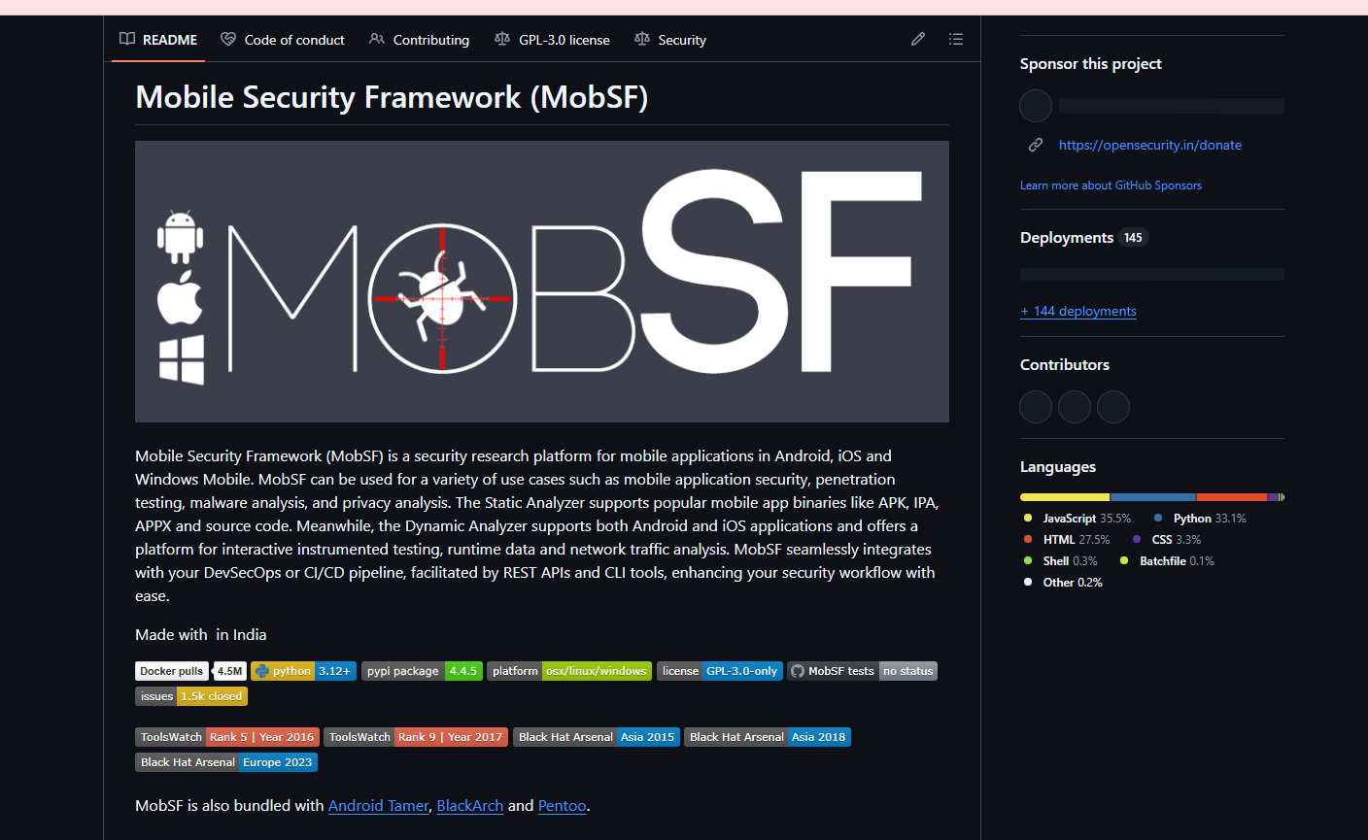
Figure 14: MobSF Dashboad

Secure Mobile Design & Mitigations :
Defending a mobile app requires a "Defense in Depth" strategy:
- Secure Storage: Moving all sensitive data into the hardware-backed Keystore or Keychain.
- Code Obfuscation: Using tools like ProGuard or DexGuard to make the code unreadable to attackers who decompile the APK.
- Runtime Checks: Implementing Root Detection or Jailbreak Detection so the app refuses to run on compromised devices.
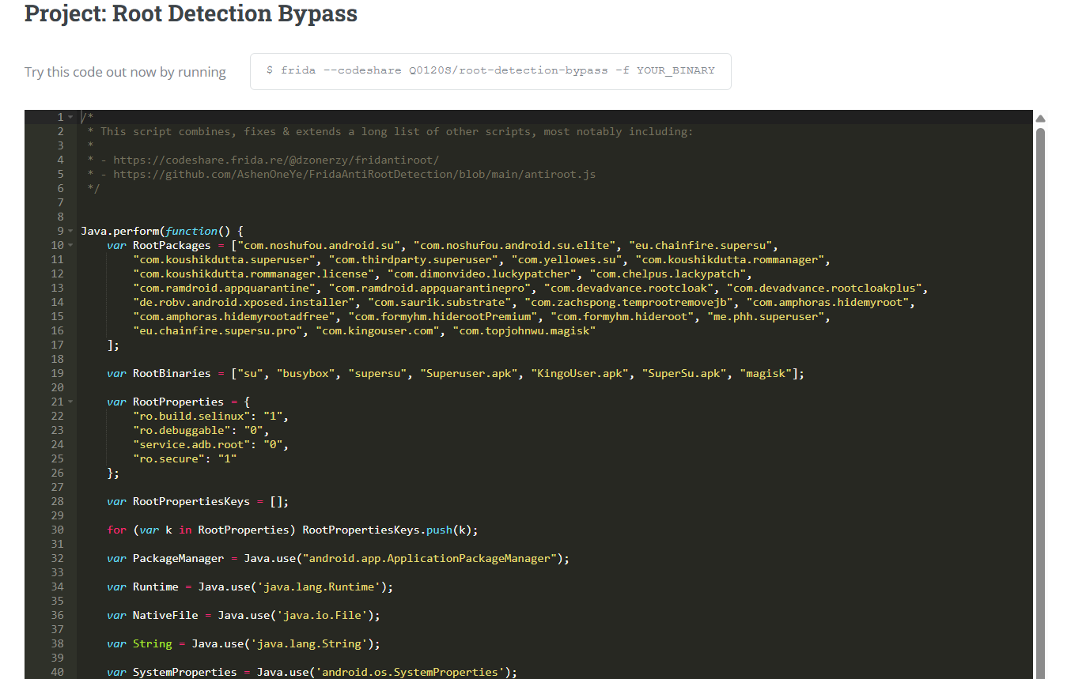

Figure 15: Project: Root Detection Bypass
Refrence Site : https://codeshare.frida.re/@Q0120S/root-detection-bypass/

Summary :
Advanced exploitation focuses on bypassing modern system protections through exploit chaining and techniques like Return-Oriented Programming (ROP) to defeat ASLR and DEP mitigations. In the realm of API security, the primary objective is identifying vulnerabilities such as Broken Object Level Authorization (BOLA) and using GraphQL introspection to map hidden data structures. Privilege escalation and persistence involve moving from a low-privileged user to a root or system administrator by exploiting SUID binaries or misconfigured services, while using "Living-off-the-Land" tactics with native tools like PowerShell to maintain stealth. Network protocol attacks target foundational communication layers through Man-in-the-Middle (MitM) strategies like ARP spoofing and the exploitation of legacy, unencrypted protocols such as SMBv1. Mobile penetration testing rounds out this security framework by utilizing static analysis with tools like MobSF and dynamic runtime manipulation with Frida to uncover insecure data storage and bypass platform-specific security checks. This entire methodology is guided by industry standards like the OWASP Top 10 and specialized technical references including HackTricks, GTFOBins, and SANS Institute research.

Comprehensive Reporting and Remediation :
Advanced Reporting & Attack Narratives
Professional reporting goes beyond listing vulnerabilities; it must provide a cohesive Attack Narrative. This narrative explains the "exploit chain"—how a tester moved from an initial foothold to a full system compromise. To quantify these risks, findings must be scored using standardized frameworks:
- CVSS (Common Vulnerability Scoring System): Provides a numerical score representing the technical severity of a vulnerability.
- DREAD Scoring: Evaluates risk across five categories: Damage, Reproducibility, Exploitability, Affected users, and Discoverability.
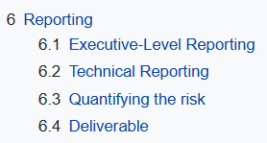
Figure 16: PTES Technical Guidline

Stakeholder Communication :
A successful report must be tailored to three distinct audiences to ensure the findings lead to actual security improvements:
- Executives: Focused on Business Risk. The report must summarize how vulnerabilities impact the "bottom line," financial standing, and brand reputation.
- Developers: Focused on Technical Fixes. This requires detailed steps to reproduce the flaw, request/response captures, and specific code-level remediation.
- Auditors: Focused on Compliance. The report must map findings to regulatory frameworks (like SOC2 or HIPAA) to show where security controls failed.
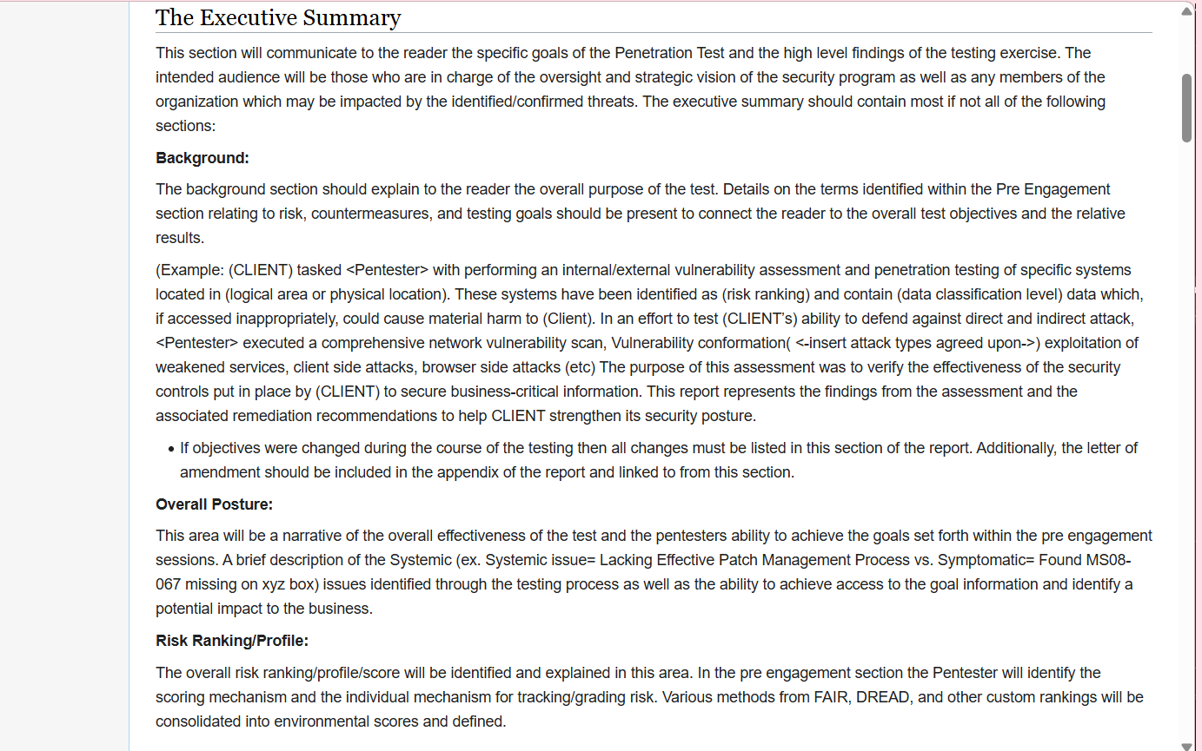
Figure 17: Executive Summary

Remediation Strategies & Mitigation Timeline :
The final objective is to provide a Strategic Roadmap for recovery. Effective remediation is not just "applying a patch"; it involves a long-term shift in security posture:
- Secure Coding: Implementing defensive programming to prevent vulnerabilities at the source.
- Zero-Trust Architecture: Moving away from a "trusted internal network" model to one where every request is verified, regardless of origin.
- Mitigation Timelines: Prioritizing fixes into immediate (Critical/High), short-term (Medium), and long-term (Low) goals.
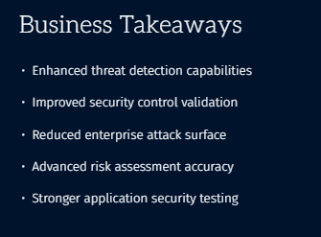
Figure 18 : Business Takeways
Summary of Learning Resource :
- PTES (Penetration Testing Execution Standard): Used for the core structure of technical and executive reporting.
- SANS Institute Templates: Leveraged to understand how to present sophisticated attack vectors and "Business Takeaways" to clients.
- HackTheBox Labs: Analyzed for best practices in documenting step-by-step exploit execution for developer remediation.

